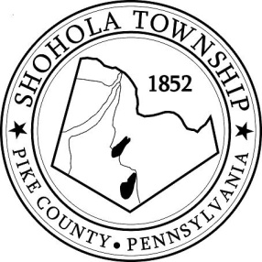
SHOHOLA TOWNSHIP BOARD OF SUPERVISORS
159 Twin Lakes Road
MUNICIPAL BUILDING, SHOHOLA, PA, 18458

AGENDA
April 11, 2024
ATTENDANCE

MEETING CALLED TO ORDER - PLEDGE ALLEGIANCE TO THE FLAG

APPROVAL OF MINUTES: Motion to approve Minutes Regular Meeting of the Board on March 14, 2024.

APPROVAL OF EXPENDITURES: Motion to approve expenditures for March 2024.

APPROVAL OF TREASURERS REPORT: Motion to approve Treasurers’ Report for March 2024.

PLANNING COMMISSION:
- None

SOLICITORS REPORT:

ANNOUNCEMENTS
- Shohola Township Park & Recreation Committee is hosting their annual clean-up day on May 11, 2024 at the Township Building. More information to come, so please keep your eye on our Facebook Page.

OLD BUSINESS:
- None

NEW BUSINESS:
- Non-working Supervisors Life Insurance Benefits (Confirm for the record that the Township wishes to continue this benefit, per instructions by PSATS.)
- Shohola Township Ambulance was awarded a $15,000.00 to go towards the purchase of a new Lifepak. Motion to purchase Lifepak at the cost of no more than $17,500.00.
- Playground Mulch – Motion to approve the purchase of certified playground mulch.
- IamResponding renewal agreement.
- Aaron Robinson presentation of a framed map of the Upper Delaware River Corridor.

CORRESPONDENCE:

REPORTS TO TH E BOARD
- Building Permits Residential Building Permits March 2024.
- Zoning and Sewage
- Road Department
- Park Committee -
- Fire Department
- Ambulance

SUPERVISORS COMMENTS:

PUBLIC COMMENTS:

