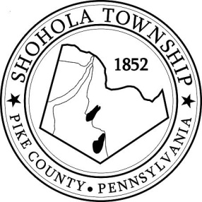
SHOHOLA TOWNSHIP BOARD OF SUPERVISORS
159 Twin Lakes Road
MUNICIPAL BUILDING, SHOHOLA, PA, 18458

AGENDA
February 10, 2022
ATTENDANCE

MEETING CALLED TO ORDER - PLEDGE ALLEGIANCE TO THE FLAG

APPROVAL OF MINUTES: Motion to approve Minutes of the Reorganization Meeting on January 3, 2022 and the Regular Meeting of the Board on January 13, 2022.

APPROVAL OF EXPENDITURES: Motion to approve expenditures for January 2022.

APPROVAL OF TREASURERS REPORT: Motion to approve Treasurers’ Report for January 2022.

PLANNING COMMISSION:
- Edwards Subdivision
- 2021 Annual Report
- Vacancy Appointment

SOLICITORS REPORT:

ANNOUNCEMENTS
- None

OLD BUSINESS:
- Shohola Camp

NEW BUSINESS:

CORRESPONDENCE:
- Letter from a realtor regarding the corner lot on 434.

REPORTS TO TH E BOARD
- Building Permits 5 Residential for January 2022
- Zoning and Sewage 7 Zoning and 6 Sewage in the Month of January 2022
- Road Department
- Park Committee -
- Fire Department

SUPERVISORS COMMENTS:

PUBLIC COMMENTS:

