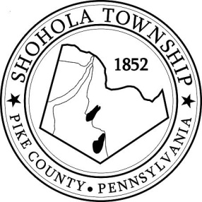
SHOHOLA TOWNSHIP BOARD OF SUPERVISORS
159 Twin Lakes Road
MUNICIPAL BUILDING, SHOHOLA, PA, 18458

AGENDA
November 11, 2021
ATTENDANCE

MEETING CALLED TO ORDER - PLEDGE ALLEGIANCE TO THE FLAG

APPROVAL OF MINUTES: Motion to approve Minutes of the Regular Meeting of the Board on October 14, 2021.

APPROVAL OF EXPENDITURES: Motion to approve expenditures for October 2021.

APPROVAL OF TREASURERS REPORT: Motion to approve Treasurers’ Report for October, 2021.

PLANNING COMMISSION:
- None

SOLICITORS REPORT:
- West Fall Ambulance

ANNOUNCEMENTS
- None

OLD BUSINESS:
- Budget

NEW BUSINESS:
- Short Term Rentals
- Food Pantry Donations

CORRESPONDENCE:

REPORTS TO TH E BOARD
- Building Permits No report
- Zoning and Sewage No report
- Road Department
- Park Committee -
- Fire Department

SUPERVISORS COMMENTS:

PUBLIC COMMENTS:

