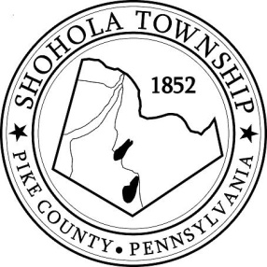
SHOHOLA TOWNSHIP BOARD OF SUPERVISORS
159 Twin Lakes Road
MUNICIPAL BUILDING, SHOHOLA, PA, 18458

SPECIAL MEETING
AGENDA

October 7, 2021

ATTENDANCE

MEETING CALLED TO ORDER - PLEDGE ALLEGIANCE TO THE FLAG

OLD BUSINESS:
- Emergency Service Options

NEW BUSINESS:
- Hailstone Economic – ARPA Funding

PUBLIC COMMENTS:

SUPERVISORS COMMENTS:

