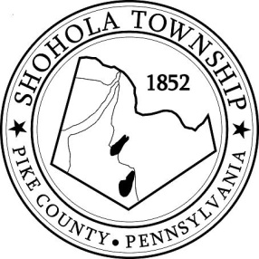
SHOHOLA TOWNSHIP BOARD OF SUPERVISORS
159 Twin Lakes Road
MUNICIPAL BUILDING, SHOHOLA, PA, 18458

AGENDA
October 14, 2021
ATTENDANCE

MEETING CALLED TO ORDER - PLEDGE ALLEGIANCE TO THE FLAG

APPROVAL OF MINUTES: Motion to approve Minutes of the Regular Meeting of the Board on September 9, 2021, Special Meeting on September 24th, 2021 and Special Meeting on October 7, 2021.

APPROVAL OF EXPENDITURES: Motion to approve expenditures for September 2021.

APPROVAL OF TREASURERS REPORT: Motion to approve Treasurers’ Report for September, 2021.

PLANNING COMMISSION:
- None

SOLICITORS REPORT:
- Park Ordinance Revision Ordinance No. 73

ANNOUNCEMENTS
- None

OLD BUSINESS:
- Resign Maps for Sardina

NEW BUSINESS:
- November Board Meeting is scheduled for Veterans Day (Discuss moving date or leave as is?)
- Budget - Advertisement
- 2022 Annual Auditor Letter of Understanding
- Zoning Fee Schedule

CORRESPONDENCE:

SUPERVISORS COMMENTS:
- Ambulance Services

REPORTS TO TH E BOARD
- Building Permits 7 Residential and 1 commercial building permits issued in September 2021.
- Zoning and Sewage 12 Zoning Permits; 9 Sewage Permits and 1 Well Permit issued in September,
- Road Department
- Park Committee -
- Fire Department

PUBLIC COMMENTS:

SUPERVISORS COMMENTS:

