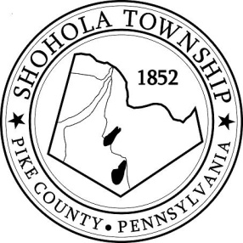
SHOHOLA TOWNSHIP BOARD OF SUPERVISORS
159 Twin Lakes Road
MUNICIPAL BUILDING, SHOHOLA, PA, 18458

SPECIAL MEETING
AGENDA

September 24, 2021

ATTENDANCE

MEETING CALLED TO ORDER - PLEDGE ALLEGIANCE TO THE FLAG

OLD BUSINESS:
- Knealing Road Agreement Resolution

NEW BUSINESS:
- Emergency Services Workshop on Options
- Pike County Development Center

CORRESPONDENCE

PUBLIC COMMENTS:

SUPERVISORS COMMENTS:

