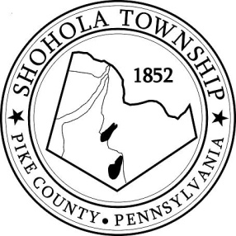
SHOHOLA TOWNSHIP BOARD OF SUPERVISORS
159 Twin Lakes Road
MUNICIPAL BUILDING, SHOHOLA, PA, 18458

AGENDA
October 13, 2022
ATTENDANCE

MEETING CALLED TO ORDER - PLEDGE ALLEGIANCE TO THE FLAG

APPROVAL OF MINUTES: Motion to approve Minutes of the the Regular Meeting of the Board on September 8, 2022.

APPROVAL OF EXPENDITURES: Motion to approve expenditures for September 2022.

APPROVAL OF TREASURERS REPORT: Motion to approve Treasurer’s Report for August and September.

PLANNING COMMISSION:
- Frazer Lot Improvement Plan
- Fitzgibbons Lot Combination

SOLICITORS REPORT:
- A.R. Real Estate Holdings
- Wayco, Inc.

ANNOUNCEMENTS

OLD BUSINESS:

NEW BUSINESS:
- Motion to advertise Budget for public perusal.
- Pike County 2022 Hazard Mitigation Plan Resolution 2022-04
- Resolution 2022-05 Act 57.

CORRESPONDENCE:

REPORTS TO TH E BOARD
- Building Permits 9 Residential permits for August and 9 Residential permits for September
- Zoning and Sewage 9 Sewage Permits, 4 Well and Zoning 10 Permits issued in September, 2022.
- Road Department
- Park Committee
- Fire Department

SUPERVISORS COMMENTS:

PUBLIC COMMENTS:

