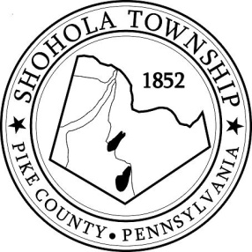
SHOHOLA TOWNSHIP BOARD OF SUPERVISORS
159 Twin Lakes Road
MUNICIPAL BUILDING, SHOHOLA, PA, 18458

AGENDA
May 12, 2022
ATTENDANCE

MEETING CALLED TO ORDER - PLEDGE ALLEGIANCE TO THE FLAG

APPROVAL OF MINUTES: Motion to approve Minutes of the the Regular Meeting of the Board on April 14, 2022.

APPROVAL OF EXPENDITURES: Motion to approve expenditures for April, 2022.

APPROVAL OF TREASURERS REPORT: Motion to approve Treasurers’ report for April, 2022.

PLANNING COMMISSION:
- Wood Subdivision
- Bekisz Lot Consolidation
- Lewis Lot Consolidation
- Kemether Lot Consolidation

SOLICITORS REPORT:

ANNOUNCEMENTS
- None

OLD BUSINESS:

NEW BUSINESS:
- Letter of Recognition for Andrew Phillips and Mark DeBlock

CORRESPONDENCE:

REPORTS TO TH E BOARD
- Building Permits 1 Residential Building Permit issued for April , 2022
- Zoning and Sewage 9 Zoning and 13 Sewage Permits issued in April, 2022
- Road Department
- Park Committee
- Fire Department

SUPERVISORS COMMENTS:

PUBLIC COMMENTS:

